**FTP Configuration**

Student Version



Huawei Technologies Co., Ltd.

|  |
| --- |
| **Copyright © Huawei Technologies Co., Ltd. 2020. All rights reserved.**  No part of this document may be reproduced or transmitted in any form or by any means without prior written consent of Huawei Technologies Co., Ltd.  **Trademarks and Permissions**  HW_POS_RBG_Vertical-150ppi.png and other Huawei trademarks are trademarks of Huawei Technologies Co., Ltd.  All other trademarks and trade names mentioned in this document are the property of their respective holders.  **Notice**  The purchased products, services and features are stipulated by the contract made between Huawei and the customer. All or part of the products, services and features described in this document may not be within the purchase scope or the usage scope. Unless otherwise specified in the contract, all statements, information, and recommendations in this document are provided "AS IS" without warranties, guarantees or representations of any kind, either express or implied.  The information in this document is subject to change without notice. Every effort has been made in the preparation of this document to ensure accuracy of the contents, but all statements, information, and recommendations in this document do not constitute a warranty of any kind, express or implied. |

|  |  |
| --- | --- |
| Huawei Technologies Co., Ltd. | |
| Address: | Huawei Industrial Base  Bantian, Longgang  Shenzhen 518129  People's Republic of China |
| Website: | <https://e.huawei.com/> |

**Huawei Certification System**

Huawei Certification follows the "platform + ecosystem" development strategy, which is a new collaborative architecture of ICT infrastructure based on "Cloud-Pipe-Terminal". Huawei has set up a complete certification system consisting of three categories: ICT infrastructure certification, platform and service certification, and ICT vertical certification. It is the only certification system that covers all ICT technical fields in the industry. Huawei offers three levels of certification: Huawei Certified ICT Associate (HCIA), Huawei Certified ICT Professional (HCIP), and Huawei Certified ICT Expert (HCIE). Huawei Certification covers all ICT fields and adapts to the industry trend of ICT convergence. With its leading talent development system and certification standards, it is committed to fostering new ICT talent in the digital era, and building a sound ICT talent ecosystem.

Huawei Certified ICT Associate-Datacom (HCIA-Datacom) is designed for Huawei's frontline engineers and anyone who want to understand Huawei's datacom products and technologies. The HCIA-Datacom certification covers routing and switching principles, basic WLAN principles, network security basics, network management and O&M basics, SDN and programmability and automation basics.

The Huawei certification system introduces the industry, fosters innovation, and imparts cutting-edge datacom knowledge.

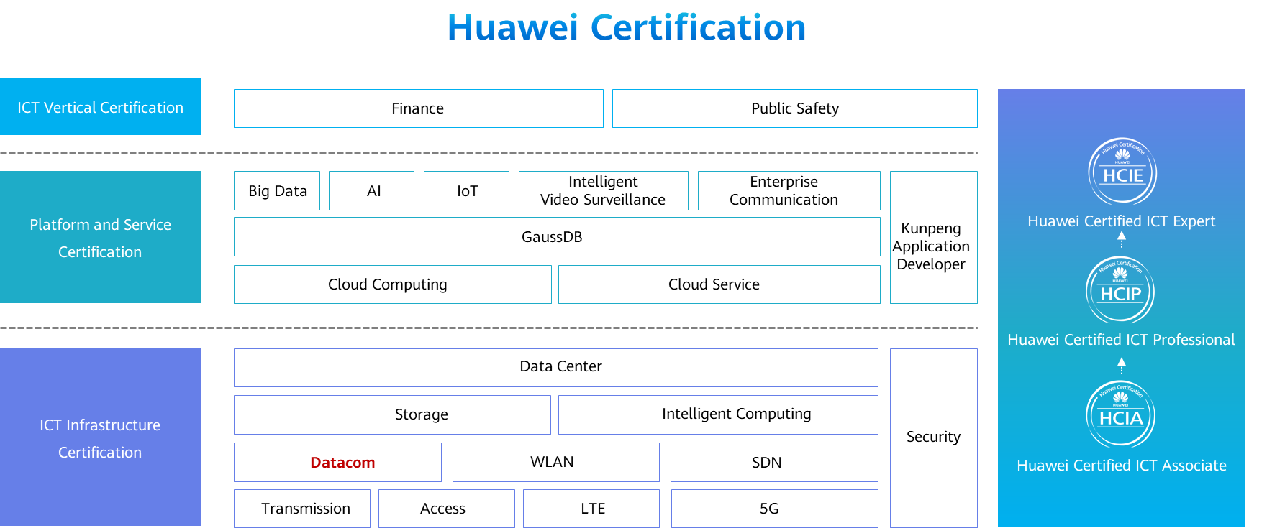

# FTP Configuration

## Background

Multiple file management modes are supported,such as File Transfer Protocol (FTP), Trivial File Transfer Protocol (TFTP), and Secure File Transfer Protocol (SFTP). You can select one based on service and security requirements.

A device can work as either a server or a client.

If the device works as a server, you can access the device from a client to manage files on the device and transfer files between the client and device.

If the device works as a client, you can access another device (the server) from the device to manage and transfer files.

## Objectives

Upon completion of this task, you will be able to:

Understand how an FTP connection is established

Learn how to configure FTP server parameters

Learn how to transfer files to an FTP server

## Topology

Lab topology

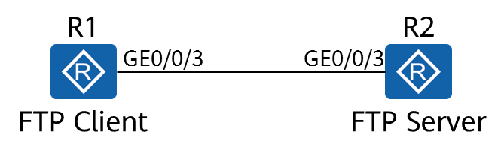

## Implementation

### Roadmap

1. Configure the FTP server function and parameters.
2. Configure local FTP users.
3. Log in to the FTP server from the FTP client.
4. Perform file operations from the FTP client.

### Procedure

Complete basic device configuration.

# Name the devices.

The details are not provided here.

# Configure the device IP addresses.

[R1]interface GigabitEthernet 0/0/3

[R1-GigabitEthernet0/0/3]ip address 10.0.12.1 24

[R2]interface GigabitEthernet 0/0/3

[R2-GigabitEthernet0/0/3]ip address 10.0.12.2 24

[R2-GigabitEthernet0/0/3]quit

# Save the configuration file for subsequent verification.

<R1>save test1.cfg

Are you sure to save the configuration to test1.cfg? (y/n)[n]:y

It will take several minutes to save configuration file, please wait........

Configuration file had been saved successfully

Note: The configuration file will take effect after being activated

<R2>save test2.cfg

Are you sure to save the configuration to test2.cfg? (y/n)[n]:y

It will take several minutes to save configuration file, please wait.......

Configuration file had been saved successfully

Note: The configuration file will take effect after being activated

# Display the current file list.

<R1>dir

Directory of flash:/

Idx Attr Size(Byte) Date Time(LMT) FileName

0 -rw- 126,538,240 Jul 04 2016 17:57:22 ar651c- v300r019c00Sspc100.cc

1 -rw- 23,963 Feb 21 2020 09:22:53 mon\_file.txt

2 -rw- 721 Feb 21 2020 10:14:33 vrpcfg.zip

3 drw- - Jul 04 2016 18:51:04 CPM\_ENCRYPTED\_FOLDER

4 -rw- 783 Jul 10 2018 14:46:16 default\_local.cer

5 -rw- 0 Sep 11 2017 00:00:54 brdxpon\_snmp\_cfg.efs

6 drw- - Sep 11 2017 00:01:22 update

7 drw- - Sep 11 2017 00:01:48 shelldir

8 drw- - Feb 20 2020 21:33:16 localuser

9 drw- - Sep 15 2017 04:35:52 dhcp

10 -rw- 509 Feb 21 2020 10:18:31 private-data.txt

11 -rw- 2,686 Dec 19 2019 15:05:18 mon\_lpu\_file.txt

12 -rw- 3,072 Dec 18 2019 18:15:54 Boot\_LogFile

13 -rw- 1,390 Feb 21 2020 10:18:30 test1.cfg

510,484 KB total available (386,448 KB free)

<R2>dir

Directory of flash:/

Idx Attr Size(Byte) Date Time(LMT) FileName

0 -rw- 126,538,240 Jul 04 2016 17:57:22 ar651c- v300r019c00Sspc100.cc

1 -rw- 11,405 Feb 21 2020 09:21:53 mon\_file.txt

2 -rw- 809 Feb 21 2020 10:14:10 vrpcfg.zip

3 drw- - Jul 04 2016 18:51:04 CPM\_ENCRYPTED\_FOLDER

4 -rw- 782 Jul 10 2018 14:48:14 default\_local.cer

5 -rw- 0 Oct 13 2017 15:36:32 brdxpon\_snmp\_cfg.efs

6 drw- - Oct 13 2017 15:37:00 update

7 drw- - Oct 13 2017 15:37:24 shelldir

8 drw- - Feb 20 2020 20:51:34 localuser

9 drw- - Oct 14 2017 11:27:04 dhcp

10 -rw- 1,586 Feb 21 2020 10:16:51 test2.cfg

11 -rw- 445 Feb 21 2020 10:16:52 private-data.txt

12 -rw- 4,096 Aug 06 2019 11:19:08 Boot\_LogFile

510,484 KB total available (386,464 KB free)

The configuration files of the two devices are saved successfully.

Configure the FTP server function and parameters on R2.

[R2]

The **ftp server enable** command enables the FTP server function. By default, the FTP function is disabled.

Other optional configuration parameters include the port number of the FTP server, source IP address of the FTP server, and maximum idle time of FTP connections.

Configure local FTP users.

[R2]aaa

[R2-aaa]

The user level is specified. The user level must be set to 3 or higher to ensure successful connection establishment.

[R2-aaa]

The authorized directory of the FTP user is specified. This directory must be specified. Otherwise, the FTP user cannot log in to the system.

Log in to the FTP server from the FTP client.

# Log in to the FTP client.

<R1>ftp 10.0.12.2

Trying 10.0.12.2 ...

Press CTRL+K to abort

Connected to 10.0.12.2.

220 FTP service ready.

User(10.0.12.2:(none)):ftp-client

331 Password required for ftp-client.

Enter password:

230 User logged in.

[R1-ftp]

You have logged in to the file system of R2.

Perform operations on the file systems on R2.

# Configure the transmission mode.

[R1-ftp]ascii

200 Type set to A.

Files can be transferred in ASCII or binary mode.

ASCII mode is used to transfer plain text files, and binary mode is used to transfer application files, such as system software, images, video files, compressed files, and database files. The configuration file to be downloaded is a text file. Therefore, you need to set the mode to ASCII. The default file transfer mode is ASCII. This operation is for demonstration purpose only.

# Download the configuration file.

[R1-ftp]get test2.cfg

200 Port command okay.

150 Opening ASCII mode data connection for test2.cfg.

226 Transfer complete.

FTP: 961 byte(s) received in 0.220 second(s) 4.36Kbyte(s)/sec.

# Delete the configuration file.

[R1-ftp]delete test2.cfg

Warning: The contents of file test2.cfg cannot be recycled. Continue? (y/n)[n]:y

250 DELE command successful.

# Upload the configuration file.

[R1-ftp]put test1.cfg

200 Port command okay.

150 Opening ASCII mode data connection for test1.cfg.

226 Transfer complete.

FTP: 875 byte(s) sent in 0.240 second(s) 3.64Kbyte(s)/sec.

# Close the FTP connection.

[R1-ftp]bye

221 Server closing.

<R1>

**----End**

* 1. **Verification**

Display the file directories of R1 and R2.

<R1>dir

Directory of flash:/

Idx Attr Size(Byte) Date Time(LMT) FileName

0 -rw- 126,538,240 Jul 04 2016 17:57:22 ar651c- v300r019c00Sspc100.cc

1 -rw- 23,963 Feb 21 2020 09:22:53 mon\_file.txt

2 -rw- 721 Feb 21 2020 10:14:33 vrpcfg.zip

3 drw- - Jul 04 2016 18:51:04 CPM\_ENCRYPTED\_FOLDER

4 -rw- 783 Jul 10 2018 14:46:16 default\_local.cer

5 -rw- 0 Sep 11 2017 00:00:54 brdxpon\_snmp\_cfg.efs

6 drw- - Sep 11 2017 00:01:22 update

7 drw- - Sep 11 2017 00:01:48 shelldir

8 drw- - Feb 20 2020 21:33:16 localuser

9 drw- - Sep 15 2017 04:35:52 dhcp

10 -rw- 1,586 Feb 21 2020 10:26:10 test2.cfg

11 -rw- 509 Feb 21 2020 10:18:31 private-data.txt

12 -rw- 2,686 Dec 19 2019 15:05:18 mon\_lpu\_file.txt

13 -rw- 3,072 Dec 18 2019 18:15:54 Boot\_LogFile

14 -rw- 1,390 Feb 21 2020 10:18:30 test1.cfg

510,484 KB total available (386,444 KB free)

<R2>dir

Directory of flash:/

Idx Attr Size(Byte) Date Time(LMT) FileName

0 -rw- 126,538,240 Jul 04 2016 17:57:22 ar651c- v300r019c00Sspc100.cc

1 -rw- 11,405 Feb 21 2020 09:21:53 mon\_file.txt

2 -rw- 809 Feb 21 2020 10:14:10 vrpcfg.zip

3 drw- - Jul 04 2016 18:51:04 CPM\_ENCRYPTED\_FOLDER

4 -rw- 782 Jul 10 2018 14:48:14 default\_local.cer

5 -rw- 0 Oct 13 2017 15:36:32 brdxpon\_snmp\_cfg.efs

6 drw- - Oct 13 2017 15:37:00 update

7 drw- - Oct 13 2017 15:37:24 shelldir

8 drw- - Feb 20 2020 20:51:34 localuser

9 drw- - Oct 14 2017 11:27:04 dhcp

10 -rw- 1,390 Feb 21 2020 10:25:42 test1.cfg

11 -rw- 445 Feb 21 2020 10:16:52 private-data.txt

12 -rw- 4,096 Aug 06 2019 11:19:08 Boot\_LogFile

510,484 KB total available (386,464 KB free)